**Activity 9.2 – Designing and Implementing a VLSM Addressing Scheme (On-Campus)**

**Topology**

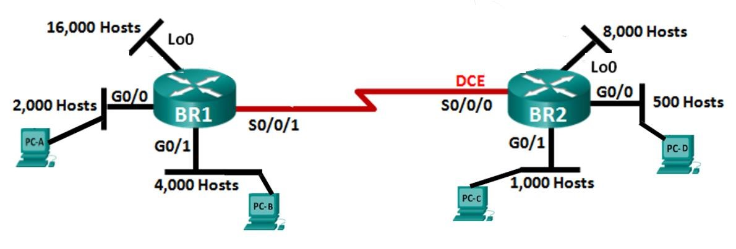

**Objectives**

**Part 1: Examine Network Requirements**

**Part 2: Design the VLSM Address Scheme**

**Part 3: Cable and Configure the IPv4 Network**



**Background / Scenario**

Variable Length Subnet Mask (VLSM) was designed to avoid wasting IP addresses. With VLSM, a network is subnetted and then re-subnetted. This process can be repeated multiple times to create subnets of various sizes based on the number of hosts required in each subnet. Effective use of VLSM requires address planning.

In this lab, use the 172.16.128.0/17 network address to develop an address scheme for the network displayed in the topology diagram. VLSM is used to meet the IPv4 addressing requirements. After you have designed the VLSM address scheme, you will configure the interfaces on the routers with the appropriate IP address information as well as configure the PCs on each network.

Note: Serial cables have two ends, one of which is called DCE and the other is called DTE. The DCE end will provide the clock and other control signals to the DTE end. For the lab, please do not touch the serial cables on the devices as they are already wired correctly.

. All rights reserved. This document is Cisco Public.

# Part 1: Examine Network Requirements

In Part 1, you will examine the network requirements to develop a VLSM address scheme for the network displayed in the topology diagram using the 172.16.128.0/17 network address.

**Step 1: Determine how many host addresses and subnets are available.**

How many host addresses are available in a /17 network? _____________________________________

What is the total number of host addresses needed in the topology diagram? ______________________

What is the minimum number of bits needed to support all the hosts? ____________________________

Given that many host-bits, how many bits are left for the network and subnets? _____________________

What is the subnet mask for a /17 network? _________________________________________________

What is the binary for the /17 subnet mask? _________________________________________________

What is the binary for IP address 172.16.128.0? ________________________________________________

How many subnets are needed in the network topology? __________________________________________

Based on the above, you will need to use VLSM to allocate the subnets within the 172.16.128.0/17 network.

**Step 2: Determine the largest subnet.**

What is the subnet name of the largest subnet?

How many IP addresses are required in the largest subnet? _______________________________________

How many bits are required to support that many hosts? __________________________________________

How many hosts can that many bits actually support? __________________________________________

What subnet mask can support that many host addresses? _______________________________________

How many actual host addresses can that subnet mask support? ___________________________________

Can you subnet the 172.16.128.0/17 network address to support this subnet? _Yes_______________ What are the two network addresses that would result from this subnetting?

|  |  |
| --- | --- |
| Network address 1: | Decimal: 172.16.128.0/18  Binary:  Subnet mask: 11111111.11111111.11000000.00000000/18  First host address: 172.16.128.1/18  Decimal:  Last host address: 172.16.10111111.11111110  Decimal: **172.16.191.254**  Broadcast address: **172.16.191.255**  Decimal: |
| Network address 2: | Decimal: 172.16.192.0/18  Binary:  Subnet mask:  First host address: 172.16.192.1  Decimal:  Last host address: 172.16.11111111.11111110 |
|  | Decimal: **172.16.255.254**  Broadcast address: 172.16.255.255  Decimal: |

Use the first network address for this subnet. That leaves the second network for further subnetting.

**Step 3: Determine the second largest subnet.**

What is the subnet name of the next largest subnet?

How many IP addresses are required in the next largest subnet? ___________________________________

How many bits are required to support that many hosts? __________________________________________

How many hosts can that many bits actually support? __________________________________________

What subnet mask can support that many host addresses? _______________________________________

How many actual host addresses can that subnet mask support? ___________________________________

Can you subnet the remaining network address to support this subnet? ____________________ What are the two network addresses that would result from this subnetting?

|  |  |
| --- | --- |
| Network address 1: | Decimal: 172.16.192.0/19  Binary:  Subnet mask: 11111111.11111111.11100000.00000000  First host address: 172.16.192.1/19  Decimal:  Last host address: 172.16.223.254  Decimal:  Broadcast address:  Decimal:172.16.223.255 |
| Network address 2: | Decimal: 172.16.224.0/19  Binary:  Subnet mask:  First host address: 172.16.224.1/19  Decimal:  Last host address: 172.16. 255.254/19 |
|  | Decimal:  Broadcast address: 172.16. 255.255/19  Decimal: |

Use the first network address for this subnet. That leaves the second network for further subnetting.

**Step 4:**

What is the subnet name of the next largest subnet?

How many bits are required to support that many hosts? __________________________________________

How many hosts can that many bits actually support? __________________________________________

What subnet mask can support that many host addresses? _______________________________________

How many actual host addresses can that subnet mask support? ___________________________________

Can you subnet the remaining network address to support this subnet? ____________________ What are the two network addresses that would result from this subnetting?

|  |  |
| --- | --- |
| Network address 1: | Decimal: 172.16.224.0/20  Binary:  Subnet mask:  First host address: 172.16.224.1/20  Decimal:  Last host address: 172.16.11101111.11111110  Decimal:172.16.239.254/20  Broadcast address: 172.16.239.255/20  Decimal: |
| Network address 2: | Decimal: 172.16.240.0/20  Binary:  Subnet mask:  First host address: 172.16.240.1/20  Decimal:  Last host address: 172.16.255.254/20 |
|  | Decimal:  Broadcast address: 172.16.255.255/20  Decimal: |

Use the first network address for this subnet. That leaves the second network for further subnetting.

**Step 5:**

How many bits are required to support that many hosts? __________________________________________

How many hosts can that many bits actually support? __________________________________________

What subnet mask can support that many host addresses? _______________________________________

How many actual host addresses can that subnet mask support? ___________________________________

Can you subnet the remaining network address to support this subnet? ____________________ What are the two network addresses that would result from this subnetting?

|  |  |
| --- | --- |
| Network address 1: | Decimal: 172.16.240.0/21  Binary:  Subnet mask: 255.255.248.0  First host address: 172.16.240.1/21  Decimal:  Last host address: 172.16.247.254/21  Decimal:  Broadcast address: 172.16.247.255/21  Decimal: |
| Network address 2: | Decimal: 172.16.248.0/21  Binary:  Subnet mask:  First host address: 172.16.248.1/21  Decimal:  Last host address: 172.16.255.254/21 |
|  | Decimal:  Broadcast address:  Decimal: |

Use the first network address for this subnet. That leaves the second network for further subnetting.

**Step 6:**

How many bits are required to support that many hosts? __________________________________________

How many hosts can that many bits actually support? __________________________________________

What subnet mask can support that many host addresses? _______________________________________

How many actual host addresses can that subnet mask support? ___________________________________

Can you subnet the remaining network address to support this subnet? ____________________ What are the two network addresses that would result from this subnetting?

|  |  |
| --- | --- |
| Network address 1: | Decimal:  Binary:  Subnet mask:  First host address:  Decimal:  Last host address:  Decimal:  Broadcast address:  Decimal: |
| Network address 2: | Decimal:  Binary:  Subnet mask:  First host address: Decimal:  Last host address: |
|  | Decimal:  Broadcast address:  Decimal: |

Use the first network address for this subnet. That leaves the second network for further subnetting.

**Step 7:**

How many bits are required to support that many hosts? __________________________________________

How many hosts can that many bits actually support? __________________________________________

What subnet mask can support that many host addresses? _______________________________________

How many actual host addresses can that subnet mask support? ___________________________________

Can you subnet the remaining network address to support this subnet? ____________________ What are the two network addresses that would result from this subnetting?

|  |  |
| --- | --- |
| Network address 1: | Decimal:  Binary:  Subnet mask:  First host address:  Decimal:  Last host address:  Decimal:  Broadcast address:  Decimal: |
| Network address 2: | Decimal:  Binary:  Subnet mask:  First host address: Decimal:  Last host address: |
|  | Decimal:  Broadcast address:  Decimal: |

Use the first network address for this subnet. That leaves the second network for further subnetting.

**Step 8: Determine the subnet needed to support the serial link.**

We will need to support one router to router network (serial link). This network consists of 2 routers (actual hosts). What is the subnet name for the router to router network?

1. ____________________________________________

How many IP addresses are required in this subnet? _________________________________

How many bits are required to support that many hosts? _________________________________

How many hosts can that many bits actually support? _________________________________

What subnet mask can support that many host addresses? _________________________________

How many actual host addresses can that subnet mask support? ________________________________ Can you subnet the remaining network to support this subnet? ___________________________

Note, by subnetting this way there will be more than enough available subnets to meet the requirement of 1 subnet for the router to router connections.

What are the first four network addresses that would result from this subnetting?

|  |  |
| --- | --- |
| Network address 1: | Decimal:  Binary:  Subnet mask:  First host address:  Decimal:  Last host address:  Decimal:  Broadcast address: Decimal: |
| Network address 2: | Decimal:  Binary:  Subnet mask:  First host address:  Decimal:  Last host address:  Decimal:  Broadcast address: Decimal: |

|  |  |
| --- | --- |
| Network address 3: | Decimal:  Binary:  Subnet mask:  First host address:  Decimal:  Last host address:  Decimal:  Broadcast address: Decimal: |
| Network address 4: | Decimal:  Binary:  Subnet mask:  First host address:  Decimal:  Last host address:  Decimal:  Broadcast address: Decimal: |

Use the first network address for BR1-S0/0/1_To_BR2-S/0/0/0.

The remaining network addresses are unused for now.

# Part 2: Design the VLSM Address Scheme

**Step 1: Calculate the subnet information.**

|  |  |  |  |  |  |
| --- | --- | --- | --- | --- | --- |
| **Subnet Description** | **Number of**  **Hosts**  **Needed** | **Network Address** | **Prefix length** | **First Host Address** | **Broadcast Address** |
| BR1 Lo0 | 16,000 |  |  |  |  |
| BR2 Lo0 | 8,000 |  |  |  |  |
| BR1 G0/1 | 4,000 |  |  |  |  |
| BR1 G0/0 | 2,000 |  |  |  |  |
| BR2 G0/1 | 1,000 |  |  |  |  |
| BR2 G0/0 | 500 |  |  |  |  |
| BR1 S0/0/1 –  BR2 S0/0/0 | 2 |  |  |  |  |

**Step 2: Complete the device interface address table.**

**Serial interface:**

**BR1-BR2 network:**

BR1 must be given the first available host address for the serial link to BR2. BR2 must be given the second available host address for the serial link to BR1.

**Ethernet interfaces:**

Each G0/0, G0/1, and Lo0 interface will get the first available address in the network that connects to them.

**PCs:**

Each PC will get the 5th available host address on their network.

|  |  |  |  |  |  |
| --- | --- | --- | --- | --- | --- |
| **Device** | **Interface** | **IP Address** | **Subnet Mask** | **Default gateway** | **Connects to** |
| BR1 | G0/0 |  |  | N/A | 2,000 Host LAN |
| G0/1 |  |  | N/A | 4,000 Host LAN |
| Lo0 |  |  | N/A | 16,000 Host LAN |
| S0/0/1 |  |  | N/A | BR2 S0/0/0 |
| BR2 | G0/0 |  |  | N/A | 500 Host LAN |
| G0/1 |  |  | N/A | 1,000 Host LAN |
| Lo0 |  |  | N/A | 8,000 Host LAN |
| S0/0/0 |  |  | N/A | BR1 S0/0/1 |
| PC-A | NIC |  |  |  | BR1 G0/0 |
| PC-B | NIC |  |  |  | BR1 G0/1 |
| PC-C | NIC |  |  |  | BR2 G0/1 |
| PC-D | NIC |  |  |  | BR2 G0/0 |

# Part 3: Cable and Configure the IPv4 Network

In Part 3, you will cable the network topology and configure the three routers using the VLSM address scheme that you developed in Part 2.

**Connecting routers:**

In the lab, the routers will already be connected via serial cables.

**Please do not touch the serial cables already connected to the routers.**

For the purposes of the lab, use the top two routers. The top router will be BR1. The second router from the top will be BR2. Cable the PCs as per the diagram.

**Step 1: Configure the routers.**

Fully configure the routers as per the standard configuration steps discussed in previous labs. Do not save the configuration.

a. Configure the routers:

Configure the routers as per the standard configuration in previous labs:

1. Assign a device name to the router.
2. Disable DNS lookup to prevent the router from attempting to translate incorrectly entered commands as though they were host names.
3. Assign **class** as the privileged EXEC encrypted password.
4. Assign **cisco** as the console password and enable login and logging synchronous.
5. Assign **cisco** as the VTY password and enable login and logging synchronous. Verify the number of vty lines are on the router.
6. Encrypt the clear text passwords.
7. Create a banner that warns anyone accessing the device:

**Unauthorised access is prohibited and you will be prosecuted.**

1. Assign *IPv4* addresses to all interfaces on Router as per the addressing table and enable them.

Configure the serial interfaces the same way that you would configure the other router interfaces:

**Example:**

HQ(config)# **interface S0/0/1**

R1(config-if)# **ip address [ip address] [subnet mask]**

R1(config-if)# **no shutdown**

R1(config-if)# **exit**

**Note:** Both ends of the Serial interfaces must be configured before the interface will show as up/up when viewing with the ip interface brief command. When you enter the ip address and no shutdown command on the first end the interface will stay down and you will likely get a similar message to this:

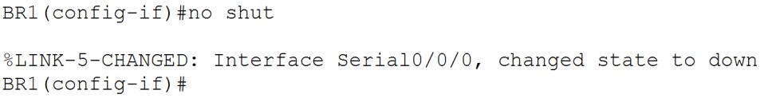

After configuring the second end of the serial cable you should see a similar message to this:

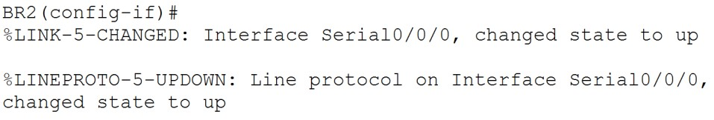 it can also sometimes take 20 seconds or so for the connection to be tested and be established.

**Note2:** If you are finding that a connection does not appear to be updating, you can try saving the file, closing it and reopening the file to try to force the simulation to update.

**Step 2: Configure the PC interfaces.**

a. Configure the IP address, subnet mask, and default gateway settings on PC-A through PC-D

 **Test and Troubleshoot the Network:**

**Note:** For this exercise, the routers do not have additional routing information configured for the remote networks. You will therefore not be able to ping PCs or interfaces that are not on your network and not attached directly to your router. Configuring routing information for remote networks is outside the scope of this course.



For example, from PC-A you can ping to the following destinations with only those directly connected to the same router (BR1) successful:

|  |  |  |  |
| --- | --- | --- | --- |
| Source | Destination | Success | Reason |
| PC-A | BR1 G0/0 | Yes | Default gateway for PC-A |
| PC-A | BR1 G0/1 | Yes | both source and destination directly connected to PC-A router BR1 |
| PC-A | BR1 S0/0/1 | Yes | Both source and destination directly connected to PC-A router BR1 |
| PC-A | BR2 G0/0 | No | Destination on different router without additional routing information |
| PC-A | BR2 G0/1 | No | Destination on different router without additional routing information |
| PC-A | BR2 S0/0/0 | No | Destination on different router without additional routing information |
| PC-A | PC-B | Yes | both networks directly connected to PC-A router BR1 |
| PC-A | PC-C | No | Destination on different router without additional routing information |
| PC-A | PC-D | No | Destination on different router without additional routing information |

Verify connectivity for the devices that are on networks that are directly attached to the same router.